



Acknowledgements:

Thanks to Baraa for his beautiful explanation, which really made things clear and more organized for me. This experience underscores a crucial principle for any learning journey: the more you can simplify concepts, the more you can excel at them and build professional work, which is why good orientation is key for the best career.

Summary:

Every business needs an inventory warehouse to contain all its physical assets, which requires good management to scale effectively and increase profits. The same principle applies to data: with the leverage of the internet and digital automation tools, the art of structuring data well and centralizing it in one place is crucial. This makes information more manageable for reporting and shaping business strategy. Our project takes this into consideration by creating a SQL data warehouse for an e-commerce startup to consolidate data and improve reporting.
My supervisor dived the project into three main parts:
- Creating the data Warehouse: We created a data warehouse that extracts, transforms, and loads (ETL) e-commerce data to improve its usability. This process involved several techniques detailed in this report, including ETL/ELT processing, data architecture design, data integration, data cleansing, data loading, and data modeling.
- Exploring our data (EDA): We performed Exploratory Data Analysis (EDA) to understand the dataset by writing basic queries, simple aggregations, and subqueries.
- Creating advanced data analyst: We answered key business questions by developing complex queries that utilized window functions, Common Table Expressions (CTEs), subqueries, and custom reports.

Tableau de matières :

Introduction: 5
Chapiter 1: Project Overview and Framework 6
1.1 Introduction: 6
1.2 The subject and its context: 6
1.2.1 Presentation of the project: 6
1.2.2 Project Identification: 8
1.3 Problem Statement: 8
1.4 Presentation of the suggested solution: 8
1.5 Project Objectives: 9
1.6 Project Steps: 9
1.7 Conclusion : 9
Chapiter 2: Data Warehouse Implementation 10
2.1 Introduction: 10
2.2 Data Architecture and its layers: 10
2.2.1 The architectures: 10
2.2.2 layers: 10
2.2.3 tools: 12
2.3 implementation: 12
2.3.1 identifying sources: 12
2.3.2 creating the database and its schema: 12
2.3.3 ETL transformations: 13
2.6 Conclusion: 13
Chapiter 3: Exploratory Data Analysis & Business Intelligence 14
3.1 Introduction: 14
3.2 exploring the data: 14
3.3 Advanced Analysis Phase: 15
3.3.1 Advanced analytical techniques: 15
3.3.2 Report Architecture: 16
3.6 Conclusion: 16
Comprehensive Conclusion: 17

Introduction:

The e-commerce startup has generated significant sales and profits over the past four years. However, after encountering numerous challenges recently, it is now crucial to structure its data effectively. This will allow the company to diagnose problems accurately and use its data to tell a compelling business story, which is a primary goal of this project.
This report will detail the various stages of the project:
- Chapter 1: This chapter presents the general context, including the problem statement, the proposed solution, functional and non-functional requirements, as well as the project's objectives and key phases.

- Chapter 2: This chapter covers the creation of the data warehouse using the tools and structures defined in the first chapter. The implementation follows a three-layer architecture: the Bronze stage (raw data ingestion), the Silver stage (cleaned and transformed data), and the Gold stage (business-ready data).

- Chapter 3: This chapter covers the transition from foundational data exploration to advanced diagnostics. We begin with Exploratory Data Analysis (EDA) using SQL to understand data structure and quality. Then, we advance to calculating Key Performance Indicators (KPIs) and performing complex analyses to diagnose business challenges, identify root causes, and provide actionable solutions.
In summary, this project is designed to shape and streamline the decision-making processes of the e-commerce business.

Chapiter 1: Project Overview and Framework

1.1 Introduction:
This chapter will introduce key business terms and data engineering concepts to establish a clear understanding of the client's objectives. This foundational knowledge is crucial for defining the project's goals and avoiding the common pitfalls that many project managers encounter.

1.2 The subject and its context:

1.2.1 Presentation of the project:
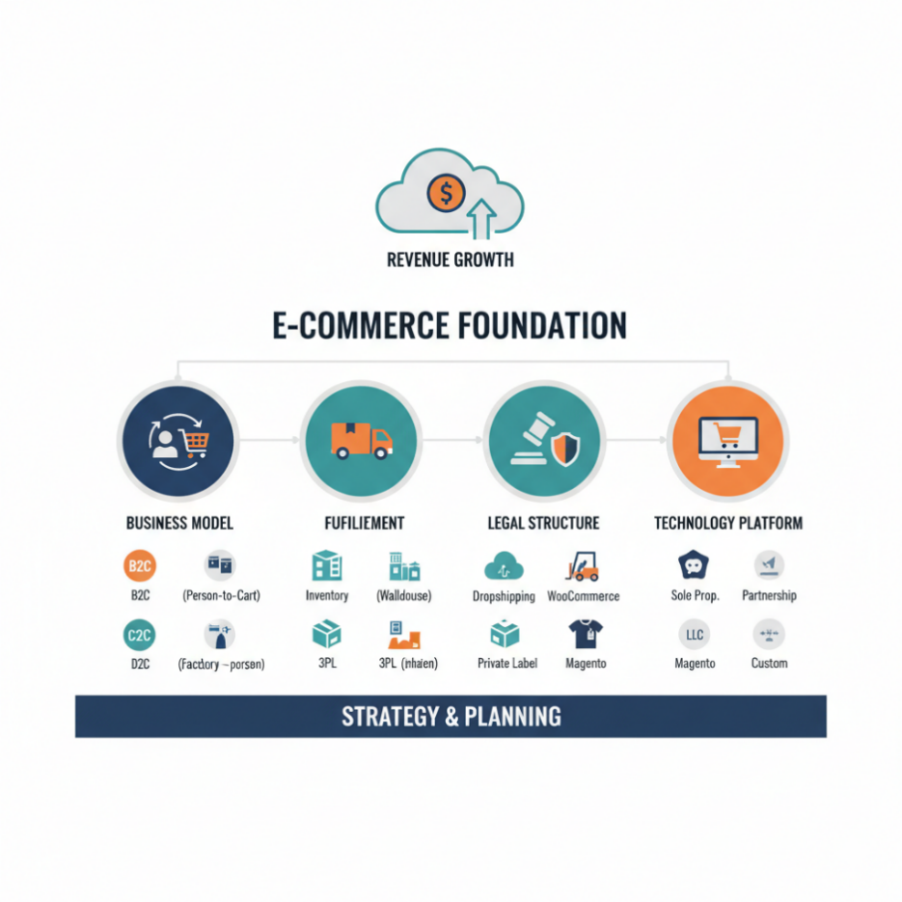
The principle of organization is fundamental to every structure we build in the world; both startups and large companies rely on it. A well-organized startup is far more likely to achieve significant revenues and healthy gross margins. Therefore, before analysing this startup's data, we must first understand its organizational framework.
Figure 1.2.1.1: E-commerce foundation.
We can view an e-commerce startup as comprising four main parts:
Business Model: This identifies the type of transactions, such as B2C (Business-to-Consumer) or D2C (Direct-to-Consumer). The chosen model fundamentally affects all other parts of the operation.
Fulfillment: This involves how the startup manages its inventory (often in a physical warehouse) and its logistical processes, whether through a 3PL (Third-Party Logistics) framework or other methods.
Legal Structure: This foundation is crucial to ensure legal safety and build customer trust, particularly through clear policies on privacy, returns, and terms of service.
Technology Platform: This is the core environment where the e-commerce business operates and excels globally. It relies on tools for automation, payment gateways, customer service management, and more.
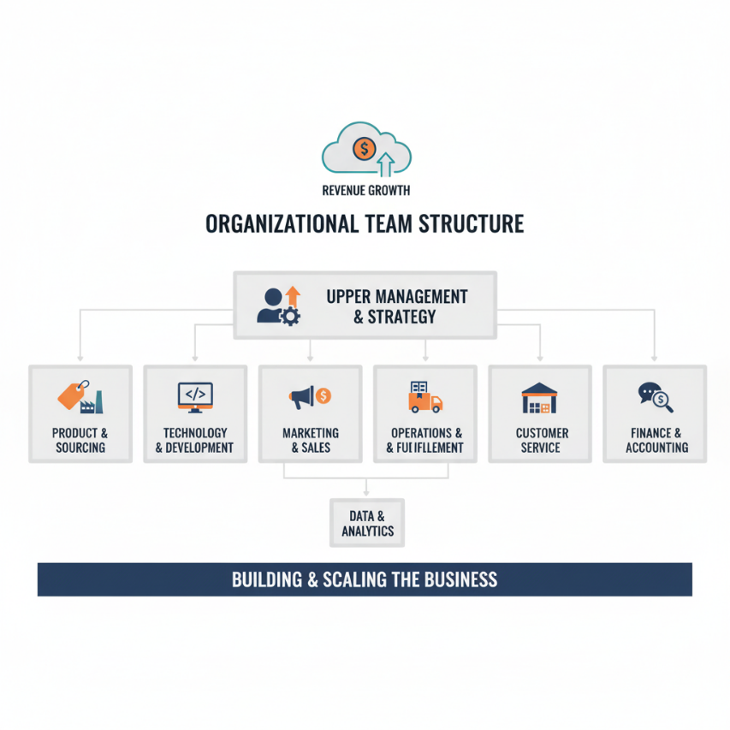
We can view an e-commerce startup as
Figure 1.2.1.2: Organisational team structure.
An e-commerce startup can be understood through its core components. While these are complex, a data analyst must focus on the overarching systems, diving into details only where necessary. The role is pivotal in shaping key areas; as illustrated in Figure 2, data professionals directly influence marketing and sales strategies, inventory operations, and fulfillment processes.

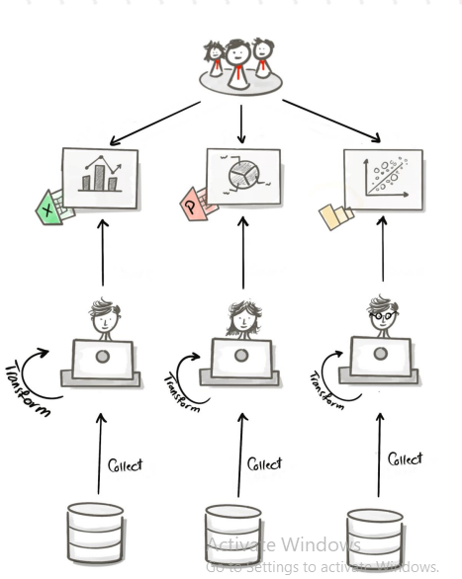
1.2.2 Project Identification:
The old approach:
Previously, the startup's process required each user to extract data from multiple sources individually. They would then perform analytical applications using tools like PowerPoint, Excel, or other analytical platforms. The fundamental problem with this approach was its inefficiency; each user had to repeatedly collect and individually transform the data, which consumed excessive time and significantly reduced overall productivity.
Figure 1.4: The suggest approach.

1.3 Problem Statement:
Our project addresses three primary challenges:
Modernizing Data Processes: Upgrading the current data approaches to make them faster and more efficient.
Ensuring Data Consistency: Eliminating widespread data inconsistencies, which we identified as a major issue during the preliminary analysis phase (to be discussed in detail later).
Enabling Data-Driven Solutions: Answering core business questions to accurately diagnose e-commerce problems and, based on those insights, formulate effective solutions.

1.4 Presentation of the suggested solution:
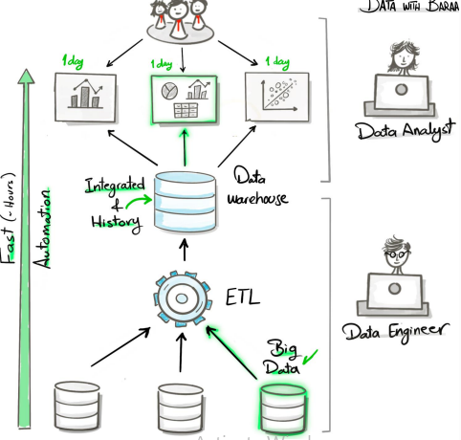
Creating a data warehouse will make data processes more efficient and engaging. Instead of manually collecting data from each disparate source and performing transformations for every use case, we can build a data warehouse that automatically integrates all these sources regardless of their size or technology (e.g., APIs, CSV files, big data). This system will handle the ETL (Extract, Transform, Load) processes automatically. As a result, users can directly access cleaned and well-structured data, allowing them to focus solely on their analytical tasks. Applications which save too much time and energy.
Figure 1.4: The suggest approach.

1.5 Project Objectives:
Our project objectives are the following:
- To design and implement a centralized data warehouse.
- To establish automated ETL (Extract, Transform, Load) processes.
- To create and populate structured tables that are ready for analysis.

Project Steps:
Data Engineer Tasks:
- Analyze client requirements.
- Design the data architecture following the principle of Separation of Concerns (SoC).
- Select the appropriate data modeling approach.
- Implementation:
  - Create the database.
  - Design the schema for each architectural layer (e.g., Bronze, Silver, Gold).
  - Develop and deploy the ETL pipelines.
Data analystcs tasks:
- Explore the data to understand its structure and quality.
- Answer key business questions through analyses such as:
    - Magnitude Analysis
    - Change-Over-Time Trends
    - Cumulative Analysis
    - Performance Analysis
    - Part-to-Whole Analysis
    - Data segmentation

1.7 Conclusion :
In summary, this chapter has established a clear and actionable plan to meet the client's requirements. By identifying key questions, we have successfully deconstructed the project into practical, manageable steps. This structured approach provides clarity for both our team and the client, ensuring a fluid and efficient execution moving forward.

Chapiter 2: Data Warehouse Implementation

2.1 Introduction:
This chapter outlines the end-to-end technical workflow for constructing the data warehouse, guiding you through the architecture design all the way to generating the refined tables used for analysis.

2.2 Data Architecture and its layers:

2.2.1 The architectures:
Selecting the right data architecture is a critical strategic decision that determines analytical capabilities and scalability.
Data Warehouse: The standard for structured, SQL-based analytics. Ideal for curated, relational data where integrity and performance for reporting are essential. It offers control but less flexibility.
Data Lake: A vast repository for raw data in any format (structured, semi-structured, unstructured). Perfect for data science and machine learning but requires strong governance to avoid becoming an unmanageable "data swamp."
Data Lakehouse: combines the key benefits of both a Data Lake and a Data Warehouse. It stores all types of data (like a Lake) while providing the reliable structure and performance (like a Warehouse) needed for Business Intelligence (BI) and Machine Learning (ML) on one unified platform.
Data Mesh: A decentralized paradigm that organizes data by business domains (e.g., marketing, sales). Each domain owns its data as a product. It solves scalability issues in large organizations but requires a significant cultural and operational shift.
The decision to implement a SQL-based data warehouse is driven by the nature of the client's data sources and their core requirements for structural integrity, controlled access, and efficient querying for business intelligence.

2.2.2 layers:
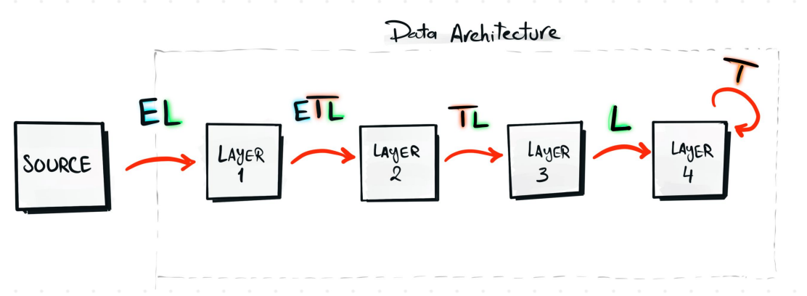
Creating a data architecture is a complex discipline that requires adhering to core principles to avoid inefficiency and disorganization. A critical principle is Separation of Concerns (SoC). In our context, this means dividing the architecture into distinct layers, each with a unique and non-transferable purpose. This modular structure ensures a smooth, organized workflow and makes it significantly easier to identify and resolve serious problems efficiently.
Figure 2.2.2: Architecture aciérie Sonasid.
Figure 2.2.2.1: Data archtectures with layers.
The warehouse architecture can be structured using several established layering methods.
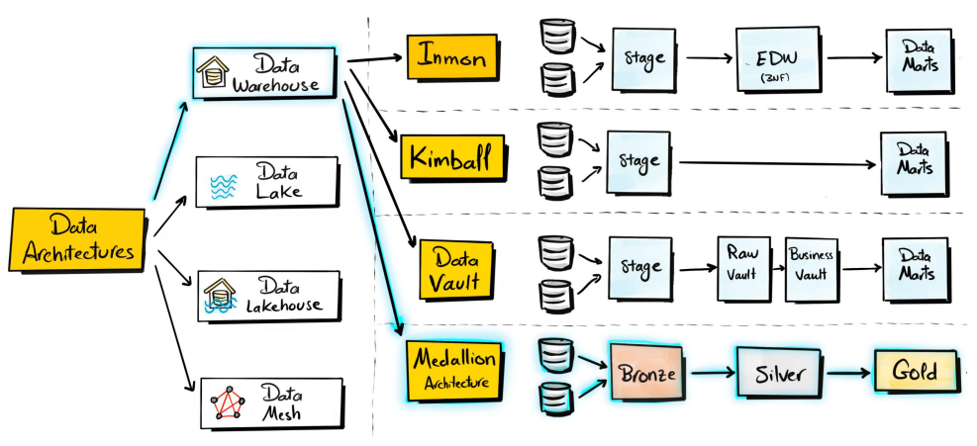
Figure 2.2.2.2: Data flows of the Data Warehouse architecture.
Based on the figure, these methodologies can be presented as follows:
Inmon: Refers to the "top-down" approach, popularized by Bill Inmon, where the Data Warehouse (EDW) is built first, acting as a single source of truth.
Kimball: Refers to the "bottom-up" approach, popularized by Ralph Kimball, where smaller, subject-oriented Data Marts are built first, often using a dimensional modeling technique (Star Schema).
Data Vault: A methodology designed for agility and flexibility, focusing on tracking relationships between business keys (Hubs) and descriptive attributes (Satellites) over time.
Medallion Architecture: A multi-layered data design pattern (often used in a Data Lakehouse) where data is progressively cleansed and transformed as it moves through "medals" or layers.
We are prioritizing simplicity and efficiency, which is why we have adopted the medallion architecture methodology.

2.2.3 tools:
While many options exist, we prioritized seamless functionality and tool integration. For these reasons, SQL Server Management Studio (SSMS) was selected.

2.3 implementation:

2.3.1 identifying sources:
The data sources consist of six CSV files, organized into two primary streams:
CRM Source: The first three files originate from the Customer Relationship Management system.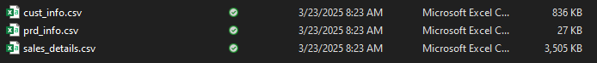
ERP Source: The remaining three files are extracted from the Enterprise Resource Planning system.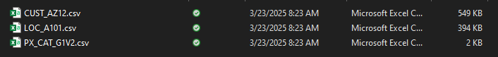

2.3.2 creating the database and its schema:
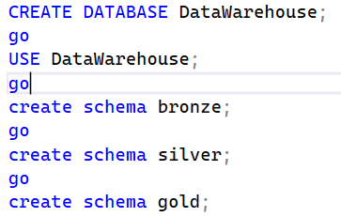
We created a database named 'sqlDataWarehouse' within the master instance, followed by the establishment of schemas to represent the previously identified architectural layers. The Bronze layer serves as the raw ingestion area for source data, preserving it in its original state for reference. The Silver layer is dedicated to core data transformations, cleaning, and enrichment. Finally, the Gold layer provides curated, analysis-ready data, which is exposed to end-users primarily through views for business intelligence and reporting.

2.3.3 ETL transformations:
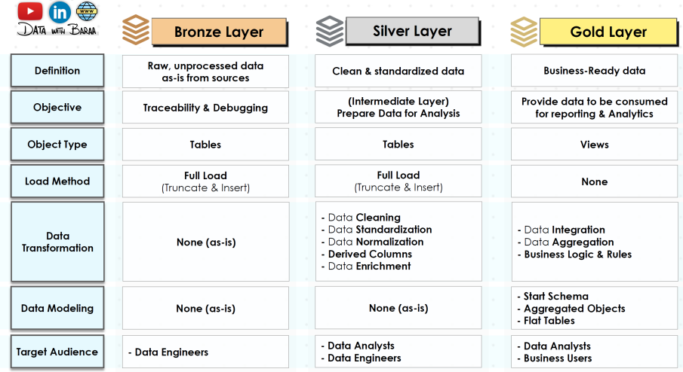
Our process is visually summarized as follows:
Figure 2.3.3: The ETL pipeline.
First, we extracted data into the Bronze layer using the BULK INSERT function, saving each CSV file following the standard naming convention bronze.[fileName]. Subsequently, we performed rigorous quality checks in the Silver layer, including verifying properly trimmed names, identifying null values in specific columns, and removing duplicates. We also addressed data inconsistencies such as future birthdates and mismatches between sales, price, and quantity columns. To resolve these, we implemented conditional logic using CASE statements to ensure data consistency. All these cleansing operations were consolidated into a single stored procedure named silver.load_silver for efficient execution. Finally, we created analysis-ready views in the Gold layer, structuring the data into a star schema with dimensional tables (dim_product, dim_customer) and a fact table (fact_sales). The subsequent analysis based on this structured data will be detailed in the final chapter.

2.6 Conclusion:
This chapter covered the complete implementation of our data warehouse using the medallion architecture. We established the Bronze layer for raw data ingestion, the Silver layer for data cleansing and quality checks through an automated ETL process, and the Gold layer where we implemented a star schema with dimensional modeling. The resulting structure provides clean, analysis-ready data for business intelligence and sets the foundation for the advanced analytics in our final chapter.

Chapiter 3: Exploratory Data Analysis & Business Intelligence

3.1 Introduction:
We are in the fun stage when we will explore the cleaned data and do some advanced calculations.

3.2 exploring the data:
There are multiple techniques to explore a database's structure. We will begin with the most commonly used ones..
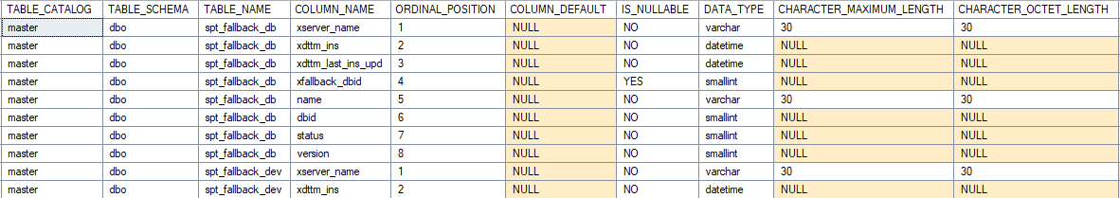
This command will display essential information about the database structure.
Figure 3.2: samble of INFORMATION_SCHEMA.COLUMNS table.
is useful to categorize the data exploration techniques we employed:
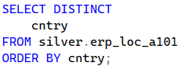
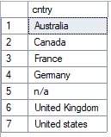
Dimension Exploration: We analyzed the distinct values within each dimension using DISTINCT to understand data diversity and identify anomalies. Example: Checking all unique product categories or customer regions.

Date Exploration: We verified temporal consistency by evaluating date ranges with functions like DATEDIFF, identifying valid time spans and potential outliers. Example: Calculating the number of years covered by the transaction history
Measure Exploration: We applied aggregations such as SUM(), AVG(), and COUNT() to summarize key metrics, providing a high-level overview of business performance and significant figures.

3.3 Advanced Analysis Phase:

3.3.1 Advanced analytical techniques:
Here the main analytical technique we used:

Magnitude Analysis: Dividing a measure by a dimension to evaluate scale, such as calculating total sales by country or total quantity by region. This helps identify key contributors and regional performance.

Change Over Time Trends: Applying magnitude analysis using a date dimension to track performance trends. This technique is essential for identifying patterns, seasonality, and supporting forecasting processes.a lot on prediction prcess.

Performance Analysis: Comparing current metrics against targets or historical benchmarks (e.g., previous year) to evaluate performance levels. This enables rapid problem diagnosis and proactive intervention before issues escalate.

Part-to-Whole Analysis: Calculating the percentage contribution of individual components to a total. When combined with dimension analysis, this reveals composition insights—for instance, we discovered that most revenue comes from the bike category, indicating potential risk from over-reliance on a single product line.


Data Segmentation: Enhancing key performance indicators by classifying data into meaningful groups using CASE WHEN statements. This technique creates new, business-relevant measures for deeper analysis.

3.3.2 Report Architecture:
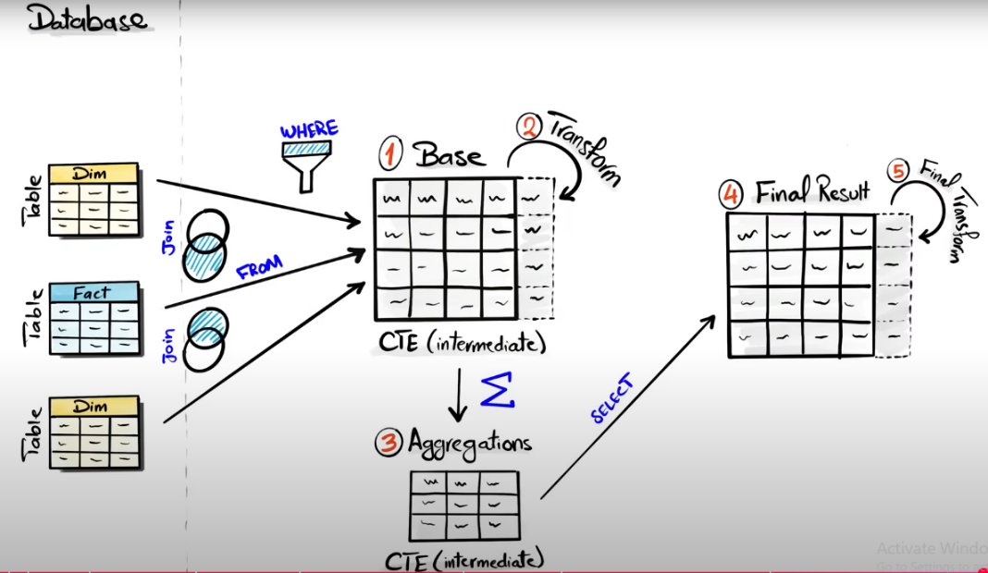
Our goal is to streamline the analytical process. In this phase, we demonstrate how we leveraged the cleaned data to build a comprehensive reporting layer using SQL.
Figure 3.3: The reporting architecture.
First, we successfully implemented the data warehouse architecture, particularly the Gold layer, which contains user-friendly views organized into dimension and fact tables. Using LEFT JOINs, we combined these tables while ensuring no loss of critical information.
Building on this foundation, we constructed two Common Table Expressions (CTEs):
- A base CTE containing key columns and advanced calculated metrics
- An aggregation CTE summarizing core business measures
These CTEs were combined to create a final SQL report table, providing analysts with fully cleaned, structured, and pre-aggregated data. This structured approach allows data analysts to focus directly on predictive analytics and visualization in tools like Power BI and machine learning platforms, without additional data preparation.

3.6 Conclusion:
This chapter detailed the transition from data to insight. We began with foundational Exploratory Data Analysis (EDA) to understand data structure and quality, then advanced to calculating sophisticated KPIs and employing advanced analytical techniques like trend, performance, and part-to-whole analysis. By architecting a final SQL reporting layer, we transformed raw data into a clean, structured, and analysis-ready asset, enabling direct integration with visualization and machine learning tools for decisive action.

Comprehensive Conclusion:

This report has chronicled the end-to-end development of a strategic data solution for the e-commerce startup, from initial problem identification to the delivery of actionable business intelligence. We began by diagnosing the critical inefficiencies of disparate data sources and manual processes, establishing a clear need for a centralized, reliable data foundation.
In response, we designed and implemented a robust SQL-based data warehouse using the medallion architecture (Bronze, Silver, Gold). This structured approach ensured a controlled flow from raw data ingestion through cleansing and transformation, culminating in a curated star schema in the Gold layer. The final phase leveraged this foundation to perform advanced analytics, answering core business questions and creating a powerful reporting platform.
In summary, this project successfully transformed the startup's data landscape from a liability into a strategic asset. The new infrastructure does not merely store data—it enables clarity, diagnoses problems, and empowers data-driven decision-making, thereby shaping the startup's future growth, optimizing operations, and mitigating risk. The foundation is now in place for scalable, informed success.

